CLUE: MIRACLE IN THE SKY (GARABANDAL)

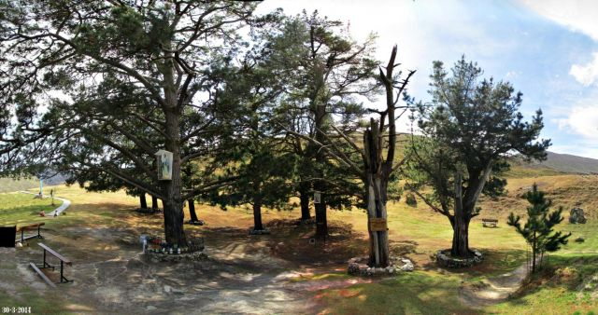
(“The Pines” at Garabandal)

COMMENT (By a soul):

In a message given to 7th Messenger, Maria Divine Mercy, in the Book of Truth, Our Lord, Jesus Christ, speaks about the antichrist and how he will claim to be Jesus Christ in the flesh walking on earth. Jesus states that He will never appear in the flesh on this earth again, and reveals:
Sunday, August 12th, 2012 @ 18:00
“I will not appear in the world as a leader. Nor will I, this time, perform miracles to prove to you who I am other than the miracle of The Warning and the miracle in the sky, which will be seen some time after The Warning takes place.”

The reason I bring up this heavenly message, is because Jesus provides a hint about the Great Miracle at Garabandal, Spain, which He calls, “...the miracle in the sky, which will be seen some time after The Warning...” He states that the Great Miracle at Garabandal will “prove to you who I am.”

Now, as I have revealed previously, I was told by St. Gabriel the Archangel in January 2017, what the Great Miracle of Garabandal consists of, but I was never shown a vision. It is quite an extensive Miracle and highly Eucharistic in nature. I know that it will prove the Real Presence of Our Lord in the Most Holy Eucharist, but honestly, I do not know if people will have the opportunity to see Jesus as He really Is in Heaven, as I was not shown a vision, etc.

However, because it will prove the Real Presence of Our Lord in the Most Holy Eucharist, that is why God the Father commands Pope Francis to be present at the Great Miracle (as I wrote in my Appeal to Pope Francis for after The Warning). If Pope Francis witnesses the Great Miracle of Garabandal, I know that it will be his greatest joy as a Jesuit priest and I believe it will prevent the Abomination of Desolation from happening, as well as halt the Great Apostasy, etc. That is one of the reasons I remain hopeful that much of the suffering during the Great Tribulation can be mitigated, etc.

Well, in this brief blog post, I want to say that there is a connection between why the Great Miracle takes place above the Pines in the skies of Garabandal, and why the Pines were first planted at Garabandal. The Pines are very special to God because of what they represent and that is why the Great Sign of Garabandal will be left at the Pines and not someplace else in the village of Garabandal. I have a link below to a very good article that tells the story of the Pines at Garabandal, which I suggest people read.

One time, the seers asked the Blessed Mother if a church should be built at the location of the Pines. The Blessed Mother replied that the Pines were “too sacred” for a church to be built on top of the land and She indicated a future spot in the village instead for a church. So, I suggest everyone learn the story about why the Pines were planted, because it means truly a lot to God. The Pines are “sacred ground.”

God bless!

FOR CONSIDERATION:

Article: “Sacred Ground” (story about planting “The Pines” at Garabandal)
http://whatisgarabandal.blogspot.com/2013/01/sacred-ground.html

More Information: The Great Miracle – Garabandal
https://maryourlady.com/our-lady-of-garabandal/the-miracle-of-garabandal/

An Appeal To His Holiness, Pope Francis the First
https://maryrefugeofholylove.com/an-appeal-to-his-holiness-pope-francis-the-first/

REFERENCE:

FROM THE BOOK OF TRUTH
(MARIA DIVINE MERCY)

“The antichrist will claim he is Me, Jesus Christ”
Sunday, August 12th, 2012 @ 18:00

My dearly beloved daughter know that just as I instruct you to prepare humanity for the salvation that is rightfully theirs so, too, does the evil one prepare souls.

He prepares false prophets to deceive God’s children so that they will accept the antichrist as their Jesus.

This wickedness is difficult for you to comprehend but with the Gift I have given you to read souls you will know instantly who these false prophets are.

They will always target you My daughter in the most devious ways for you will be their number one adversary. Yet, their lies, couched in what will seem to be like the Holy Words of God, hide the biggest lie of all.

They will declare that the false prophet will be the true Pope.

They will declare, subtly at first, that the antichrist will be Christ the King.

When they seduce poor souls that their messages come from God, such souls will be none the wiser.

I must warn all of God’s children. I will never come in the flesh the second time.

I will not appear in the world as a leader. Nor will I, this time, perform miracles to prove to you who I am other than the miracle of The Warning and the miracle in the sky, which will be seen some time after The Warning takes place.

The antichrist will claim he is Me, Jesus Christ. This abomination has been foretold.

Who to believe children is no easy task for many will come in My Name. But know this.

The evil one, through his false prophets, will never tell you to pray to the Holy Spirit or receive the Sacrament of the Holy Eucharist.

He will never admit that I, Jesus, the Son of Man came as the Messiah in the flesh to redeem man from sin.

He will never ask or encourage you to say the Holy Rosary or show allegiance to My beloved Mother.

Be on your guard. Stay awake and only follow My instructions.

The evil one is trying to form an army amongst my followers. Although his other army is well established on earth he now targets those who believe in Me, your Jesus, because he wants to hide his evil deeds behind holy people.

He will use their love for Me as a shield to hide the lies he intends to inflict upon the world.

Trust in My Words and do not deviate from the Truth as it is being given to you, through these My Holy Messages to the world at this time.

YOUR JESUS

