CLUE: THE FOUR LIVING CREATURES AND GREAT SIGN OF GARABANDAL

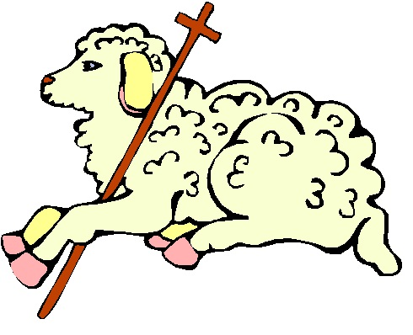
COMMENT (By a soul):

As I have revealed, earlier this year in January 2017, I was told by St. Gabriel the Archangel what the Great Miracle and Great Sign of Garabandal consist of, although I was not given a vision. I was also told about the Great Sign of Medjugorje. And so, I have been giving hints and clues about them, in order to build up suspense for both gifts from God.

Well, in this brief blog post, I want to speak about the Great Sign of Garabandal, as the Blessed Mother gave a big hint in a message through Locutions To The World. The entire message is below, but here is the specific passage that I am referring to:

May 13, 2012

“...There will be extraordinary divine signs, able to be seen and experienced by all. These signs will call the world to repentance. They are not meant as curiosity pieces or objects of ridicule. They will be living, powerful, divine signs marking my presence and calling attention to my messages. These signs will fulfill my prophecies and show to all who believe that I am present to help the human race in the time of trial.”

“The signs will also point to all the many teachings and instructions that I have given. The signs will be powerful and accompanied by inner lights which everyone in the world will experience. There will be a universal call to repentance...”

Now, the big hint from Our Blessed Mother is that they will be “living, powerful, divine signs”—key emphasis on the word, “living.” I have also indicated previously, that “the Great Miracle is something that exists in eternity before The Throne of God.”

Although this hint will not make sense to people, the best description of the Great Sign of Garabandal, are the “four living creatures” that are before the Throne of God that do not stop exclaiming day and night, “Holy, holy, holy is the Lord God almighty, who was, and who is, and who is to come.” (Book of Revelation, Chapter 4, Verse 8). The Great Sign of Garabandal is something that gives Great Glory to God; and because I know exactly what it is, I believe it is something very sacred in the Eyes of God.

Now, the seers at Garabandal have said these words: "there would be a permanent sign at the pines that everyone will be able to see and touch but not feel." However, I have to take exception to what they have said.

I believe that people will be able to see the Great Sign, but not touch it or feel it. It is because I know the exact nature of what it is, I believe due to its sacredness, that the Great Sign is too holy for people to touch. Everyone can see it but not touch it.

That being said, the Great Sign of Garabandal involves light, so even though I never saw a vision of it, I think it will either be all-light or like smoke—something you can see but not directly touch. The Great Sign definitely has an ethereal aspect to it.

And so, that's my clue. God bless!

REFERENCE:

LOCUTIONS TO THE WORLD

May 13, 2012
“The Great Signs”

MARY

“There is too much darkness and confusion in the world for anyone to see clearly. When I send my prophets, their message is analyzed according to human reason. Then it is distorted and rejected. In this situation, no one can fully understand or perceive the truth. So, I myself speak, in very simple words. I do not want these analyzed by your mind but received by your heart. Let us begin.”

“Man will finally accept the word of God, only when he is trembling and shaking because he has seen divine signs. Even then, many will harden their hearts, refuse to repent, and lose the last chance that they have for eternal salvation. To avoid this, I must speak now to prepare your hearts.”

Extraordinary Signs

“There will be extraordinary divine signs, able to be seen and experienced by all. These signs will call the world to repentance. They are not meant as curiosity pieces or objects of ridicule. They will be living, powerful, divine signs marking my presence and calling attention to my messages. These signs will fulfill my prophecies and show to all who believe that I am present to help the human race in the time of trial.”

“The signs will also point to all the many teachings and instructions that I have given. The signs will be powerful and accompanied by inner lights which everyone in the world will experience. There will be a universal call to repentance. Many will not understand what is happening because they have set aside the things of God. Yet, even to them, these lights can be beneficial.”

A Decisive Moment

“What a moment that will be! A decisive moment for mankind. The benefits of that gift are not guaranteed. People must take advantage of the gift and repent of their sins. Otherwise, the inner light will just stand in judgment upon them – that God has given them such a great gift and they rejected it. I speak so all will accept the light.”

