(Source: https://revelacionesmarianas.com/en/reina_y_madre_de_los_ultimos_tiempos.html)

QUEEN AND MOTHER OF THE END TIMES

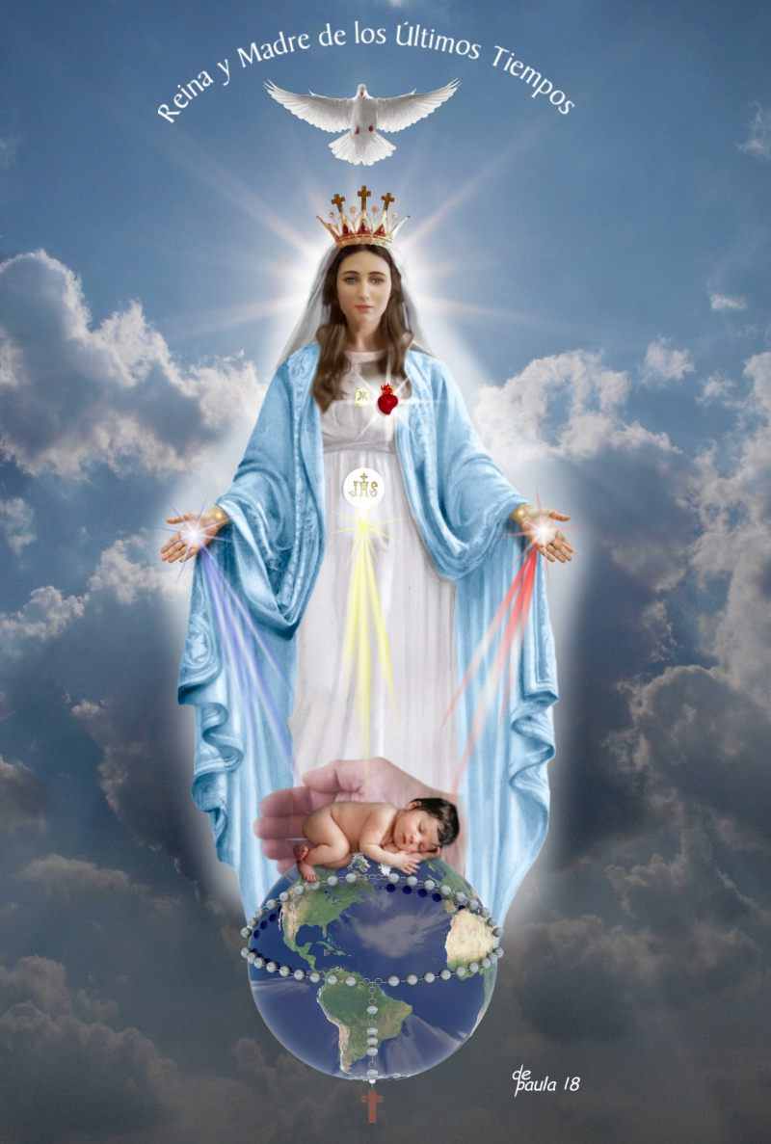

Estelí August 3, 2018

NEW INVOCATION OF THE BLESSED VIRGIN MARY: ¨QUEEN AND MOTHER OF THE END TIMES¨

On Monday, August 28 of the year of the Lord 2006, a new invocation of the Blessed Virgin Mary was revealed to Luz de María by our Lord Jesus Christ under the title of "QUEEN AND MOTHER OF THE END TIMES". A GREAT PART OF THE INVOCATIONS TO THE BLESSED VIRGIN MARY ARE GATHERED IN ONE SINGLE IMAGE THAT REPRESENTS HER.

Later the Heavenly Mother dictated a prayer for all of God’s People, with which She invites us to invoke Her especially in these instants of great tribulation and confusion inside and outside the Church.

Grateful to Heaven for such a great heavenly gift, we exhort the People of God to receive with faith and gratitude over this divine help that springs from the loving Will of God that wants to protect all of us in the present and the future through the maternal help of the “Queen and Mother of the End Times".

I grant the “imprimatur” to this new invocation, to the prayer with which we can implore Her with confidence and to the representation or image that artistically expresses the vision had by Luz de María, at the same time I extend the invitation to participate in the novena to prepare for the feast of our ¨ QUEEN AND MOTHER OF THE END TIMES¨ whose feast day will be on August 28.

† IMPRIMATUR,
Bishop of Diocese of Estelí

DESCRIPTION OF THE IMAGE

I share with you the description that our Blessed Mother explained to me about the symbols that make up the image of this invocation:

"Upon My image rests the Holy Spirit, of whom I am Temple and Tabernacle.

My Crown has three Crosses: the middle Cross belongs to My Son's Cross, the one on the right to remind you of Divine Mercy and how the repentant thief attained forgiveness and won Heaven, and the one on the left for you to keep in mind the one who mocked My Son, being on a cross, and condemned himself.

The Scapular on My Chest is a sign of the commitment that My children have so that their life be alike to Mine: in obedience and faith to the Word of God.

My Sacred Heart illuminates the life of men and, in the end, My Immaculate Heart will triumph.

In My Womb, My Son is seen in the Holy Eucharist, unfolding His Love through yellow rays.

On the wrists of My Hands you will notice a star, so that you remember that I am the Morning Star of the New Dawn and guide the People of My Son.

My Hands shine with light so that My children do not go astray and see the light of the beacon of My Hands, from which rays emanate that converge with the rays of My Son, present in the Holy Eucharist and deposit themselves in blessing on the newborn child, who represents, in the first place, Our beloved Angel of Peace—fruit of the Trinitarian Will—who is presented to Humanity by the Hand of God the Father who is guarding him. Second, the child represents the Holy Remnant. That Holy Remnant that is being protected and maintained on the Earth of peace, by the Hand of God the Almighty Father.

The Earth, at this instant, is surrounded by My Holy Rosary, just as the renewed Earth will continue to be surrounded by My Holy Rosary. And with each Our Father and every Hail Mary that you have prayed in the Rosaries and in other prayers, you have multiplied them to infinity, because prayers will always bear fruits of life and in abundance.

The Earth is shining, and the darkness will have passed.

My Invocation represents the Hope of a new Heaven and a new earth.

Amen."

NOVENA TO THE QUEEN AND MOTHER
OF THE END TIMES

As a preparation to the Festivity of August 28th.

Start date: August 20th

End date: August 28th

The following Novena has been dictated to Luz de María by Our Blessed Mother. Each day of the Novena, Our Blessed Mother wishes that, united with Her, we say the initial prayer, the prayer of the day and lovingly carry out the offering that She indicates. In the same way, She also reminds us:

"As all My children know, during a Novena it is necessary to attend the Holy Eucharist."

Note: This Novena can be done with love and devotion at any time of the year.

PRAYER TO THE QUEEN AND MOTHER
OF THE END TIMES

Beloved children, I invite you to pray:

Divine Father, Eternal and Omnipotent,
Holy Son, Word Incarnate,
Holy Paraclete, Divine Spirit,
Three Persons in one True God.

Pour out Your Most Holy Blessing upon this creature
who cries out before Your Divine Majesty.
Take my hand so that I am not separated from Your Protection,
give me the immovable hope
of the encounter with Your Glory.

May my soul be sculpted by Your Holy Spirit
and I find the discernment
that leads me to the Truth of Your Word
and I do not deviate from the Holy Path.

Most Holy Trinity, you have bequeathed to Your People
the blessing of possessing
the Queen and Mother of the End Times,
to intercede for and defend Your People.

I welcome such an exalted Queen and Mother,
I take Her blessed Hand
and I surrender to Her Maternal Instruction
so that, together with Her, I may be a doer of Your Will.

Mother who guides, Mother who intercedes,
Mother who protects this aimless Humanity,
be my helm at this instant,
so that, before the clutches of evil,
my soul does not succumb out of weakness.

Give me the willpower so that I may not fear the waiting,
But rather that I may fear falling into the insinuations of evil
and do not let my soul be lost in the darkness of evil.

Queen and Mother of the End Times,
come, receive me and teach me
to wait for the Trinitarian instant,
may it not be I who wishes to advance the hour,
but under the protection of Your faithfulness,
may I be Your reflection and may no instant
frighten me before which it looks like I may succumb.

Queen and Mother of the End Times,
Make Love, Faith, and Hope, be reborn in me
and also, the courage to live like You,
nourishing myself with the Trinitarian Will
and continuing with the fervent faith that You will lead me
towards the longed-for encounter with the Father, the Son and the Holy Spirit, being reborn to the new life beside the Most Sacrosanct Trinity.

Amen.

FIRST DAY
Pray for the conversion of Humanity.

Prayer of the day:

Queen and Mother look at me, I live alone,
come to me, I need Your Love.
Place my petitions in Your Heart,
which I beg you to accept: (add personal petitions here).

Illuminate me with the rays of Your Obedience,
Faith, Hope and Charity.
I wish to help my brothers and sisters with Your same Obedience,
so that together, we may know Your beloved Son. Amen.

Offering: I invite you to offer My Son obedience.

SECOND DAY
Pray for those who do not know the Most Holy Trinity.

Prayer to the Queen and Mother of the End Times...

Prayer of the day:

May Your Heart be the treasure where I discover
the infinite dimension of Trinitarian Love.
Do not let me be an ungrateful child who denies the Creator,
do not let me be a blind creature who denies Redemption,
do not let me be so deluded as to think that without the Holy Spirit, my conscience can be enlightened to discern between
what is of God and what is not of God.

Queen and Mother, I beg You that I may be
an instrument for the good of my brothers and sisters. Amen.

Offering: On this day I ask you to carry out works of mercy towards the needy.

THIRD DAY
Pray that the persecutors and enemies of My Son's People will be dispersed.

Prayer to the Queen and Mother of the End Times...

Prayer of the day:

Queen and Mother of the weighed down,
look for me, I call You with all my strength.
Do not allow my reason be greater than my heart,
ignite in me the courage to take the path of conversion.

Even if I be persecuted on Earth for loving Your Son,
bring Your Angels and come with me,
come and teach me to resist by looking,
at every moment, Your Motherly Face,
may Your gaze penetrate my thoughts,
and may I not drift away no matter how much
the world offers me the fruits that would lead me to sin.

Receive, Queen and Mother, my wishes
and in You, make them come true. Amen.

Offering: I call you to adore My Son.

FOURTH DAY
Offer this day for your personal conversion.

Prayer to the Queen and Mother of the End Times ...

Prayer of the day:

May the joy of looking at You lead me to continue
delivering the best of me each and every day.
I offer myself, so You can polish me, I do not want to be lost,
evil confuses me and the mundane overwhelms me,
I am going through difficult moments, my humanity falters...

Queen and Mother fill my heart with Your Strength
and my mind with Your Obedience and Firmness.
I want to go forward towards Eternal Life,
I yearn for my human ego to be an instrument
for spiritual growth.

Queen and Mother fill me with Your Gifts,
help me to overcome the need
of wanting to always be the best and the most applauded.
Come, Queen of Heaven and Mother of Your Son’s People,
make me a new person,
innocent, that surrenders at Your feet
to grow under the protection of Your Purity. Amen.

Offering: Share food with the needy.

FIFTH DAY
This day I call you to love your brothers
and sisters and not to reject them.

Prayer to the Queen and Mother of the End Times...

Prayer of the day:

My Jesus, teach me to look at Your Face in my fellow men,
I need my eyes not to be so human,
I need them to be more spiritual so,
they will see with Your same Love.

Queen and Mother share with me the light from Your Gaze
which You possess from the Holy Spirit.

Come, I beg of You, so that my mind, my thoughts
and my heart be more in the Divine way
so that pride, prejudices, and feeling saved and
more than my brothers and sisters be detached from me.

My Jesus, I want to be fully aware of what it is to be Your son
and a member of Your People.
Aware so that I not feel saved by saying that I love you,
instead, that I realize that he who loves You
loves his neighbor without distinctions. Amen.

Offering: I ask you offer Holy Communion for your brothers and sisters, those you do not love as you should.

SIXTH DAY
On this day, you will bless all the brothers and sisters that you see; you will bless them all with your mind, with your thoughts and with your heart: all of them.

Prayer to the Queen and Mother of the End Times...

Prayer of the day:

Queen and Mother of the End Times,
come and take my mind, my thoughts and my heart,
so that it be You who blesses my brothers and sisters in me.

As I am incapable of blessing without distinctions and
not having fulfilled the First Commandment,
I pray for Your Motherly help,
that I be obedient to the Commandment of Love.

Queen and Mother, come and renew my heart so
I may love my brothers and sisters as Your Son loves:
without distinctions.

Give me a renewed mind and thoughts
not to create obstacles in my heart that interfere,
thereby denying myself Eternal Salvation. Amen.

Offering: On this day you will resolve to be love to your fellow men so that jealousy, envy, vanity, desire for possession, lack of love, and materialism disappear.

SEVENTH DAY
Offer this day so that fidelity grows, and you do not wane during the serious instants.

Prayer to the Queen and Mother of the End Times...

Prayer:

Loving Father, Merciful Son, Holy Spirit, the comforter,
Be adored everywhere.
Omnipotent and Everlasting God,
send Your Holy Spirit upon me,
I prostrate myself before Your Majesty,
I humbly implore for the Gift of Fortitude
that I do not decline no matter how strong the trials may be.

Most Holy Trinity, I abandon myself in You
so that I awaken in this instant
and my vision not be clouded by modernisms.

Give me strength to remain faithful to Your Word
and to be compliant of Your Commandments,
convinced that this is the good for
my salvation and that of my fellow men.

Give me Holy Wisdom to understand that
in order to love you, I must deepen my knowledge
and understanding of Your Word.

Queen and Mother of the End Times,
I come to Your Shelter so that You be the beacon
that illuminates my path. Amen.

Offering: Children, on this day you will meditate on how far away man is from God.

EIGHTH DAY
Make reparation for the distance of man towards his Creator and the unbelief towards His Word.

Prayer to the Queen and Mother of the End Times...

Prayer:

Queen of my life, come, take my physical senses
and lead them to recognize the evil that exits
in all that surrounds us,
so that my senses will not lead me to what is improper.

I offer you my human will,
keep it in Your Hands and hold it,
so that I will not be indifferent
to the Divine Love nor to my neighbor.

I surrender to Your Maternal Guidance,
as Your child who does not want to take
the wrong path and lose Salvation. Amen.

Offering: On this day, you will do an act of mercy.

NINTH DAY
I call you to consecrate yourselves.

Prayer to the Queen and Mother of the End Times...

Consecration:

Queen and Mother of the End Times,
I am your child, receive me, I give to You my life
and in Your Hands, I place my will,
all I have and all I am, my aspirations, desires and projects.

Take away from me all attachment to material things,
so that I will look for possessions
which cannot be seen because they are spiritual.

I consecrate my life to You today, Queen and Mother,
I freely surrender to Your Protection
in such difficult instants in which I live,
be the Ark that will lead me to remain afloat
without sinking in the middle of the purification.

May the Rays from Your Hands enlighten my mind,
my thoughts and my memories that they be healed,
my sufferings, so that I offer it and my falls,
so that You will lift me.
Illuminate my reason so that it does not compete with my faith,
but one be the light of the other.

I consecrate myself to You and surrender to You
within the freedom of the God´s children. Amen.

AFTER DOING THIS NOVENA YOU WILL RECEIVE FROM ME:

† The virtue of Hope, so that you do not desist in the instants when you feel the path seems long, and so that the happiness of being a child of God will not move away.

† I will not allow despair to take hold of you, neither will allow you to believe that My Son has abandoned you. Whoever asks for mercy of heart and firm purpose of amendment will receive them.

† I will provide you with the Gift of Wisdom, so you will be children attached to the Divine Word and not be confused, as children who look the Mission that God has entrusted to them. In this way you will not harm the Divine Plans.

† You will receive the Gift of Strength so that your faith will be firm and strong, persevering, and at the same time, love guides all.

† Families will be more united and fraternity among brothers and sisters will be stopper to evil.

† I will provide love between spouses so that it increases.

MY BLESSING WILL BE WITH YOU AS LONG AS YOU ACT WITHIN WHAT IS GOOD.

I love you.

